Using the NM Assistant app:

There are two basic uses of this app, the more common usage being the first:
- Save one or more offline maps.
  - A map showing a track you wish to hike
  - A map showing only a region (no track) where you will hike
In either case, you can pull up the map for display - with or without internet – and a pulsing blue dot with show your location.
- Create a track file (.gpx) while you hike. It can be shared, emailed or saved when you end the hike.

BASIC USAGE: Offline Maps
When you first open the app, it will show a large area map centered on Albuquerque. When you ‘Allow Location Services” the map will re-center on your current US location wherever you are. This location is saved, so that if you go to a place where there is no internet, it will default to this (last opened) location.


The Menu:
To use offline maps, you must first save one. Click on the ‘Menu’ icon to open the menu.

You will see the following menu [The menu can be closed by tapping anywhere outside the men]
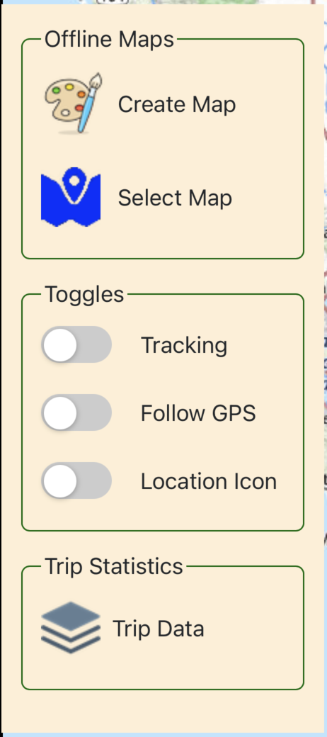
The first thing to do is to tap “Create Map”.
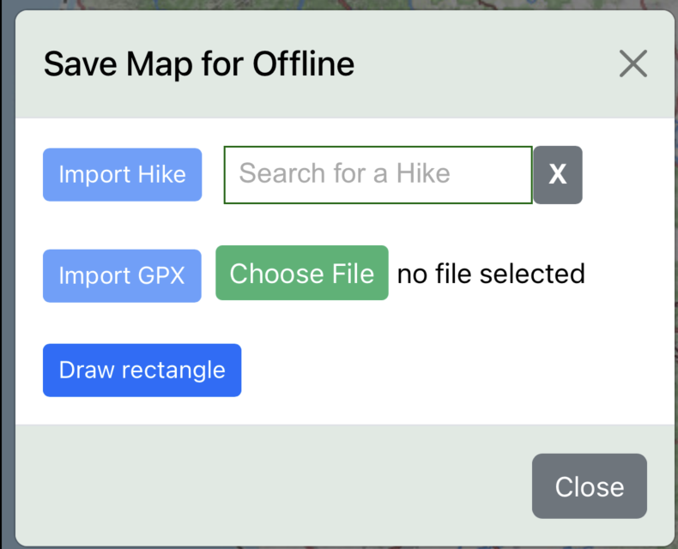
You will see the following:

This shows that there are three ways to proceed:
- Import a hike directly from nmhikes.com
- Import any .gpx file (from your phone’s file folder, or other app)
- Pan the map to an area you wish to save for later, and draw a rectangle to capture it.
Each of thes three methods is discussed:
- Site hike: simply begin typing the name of the nmhikes.com hike into the search box, then click on the hike. It will display in the search box, and the “Import Hike” button will now be enabled.
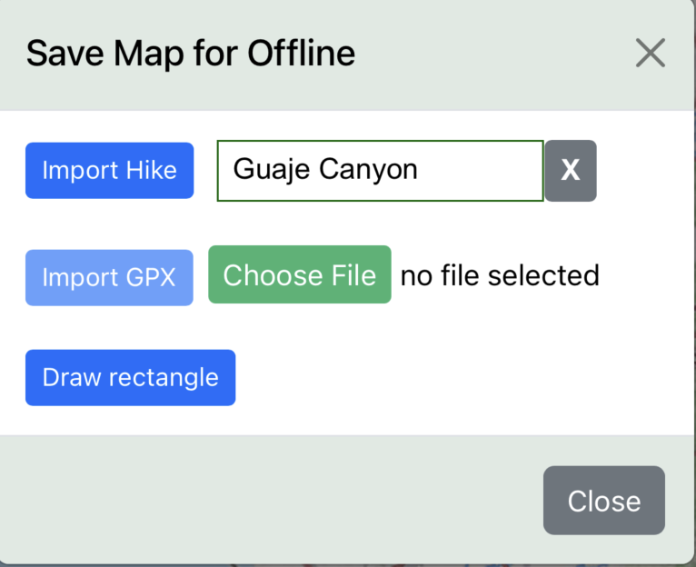
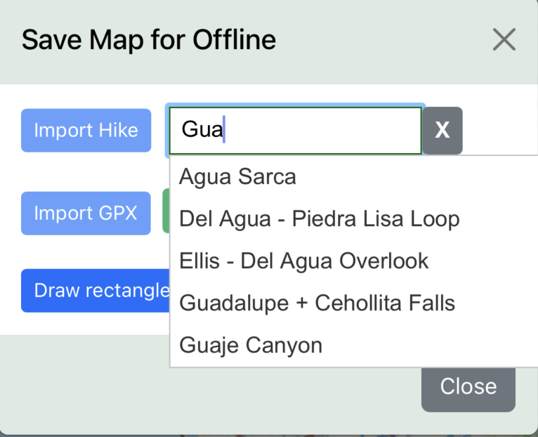

-- >

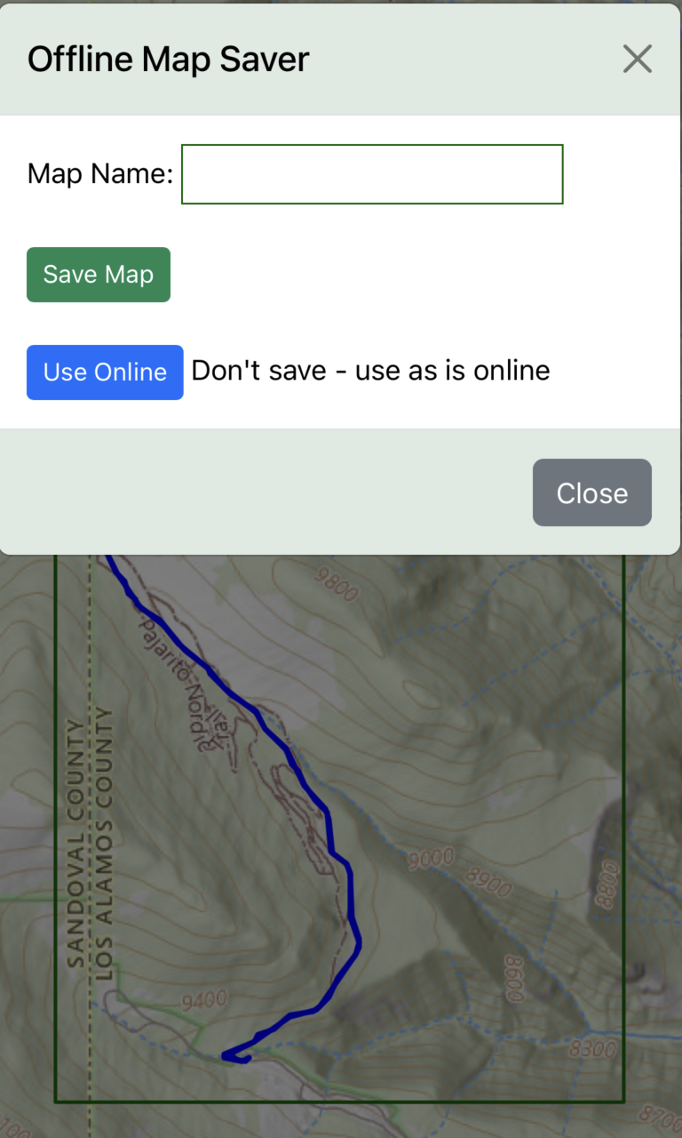
Click the ‘Import Hike’ button to display and save the map:

Enter a name for the map
Then tap ‘Save Map’. If you don’t want to save it and just want
to use it while connected to the internet, tap ‘Use Online’

If you are saving the map, you will see a Save Status
window showing the progress of saving
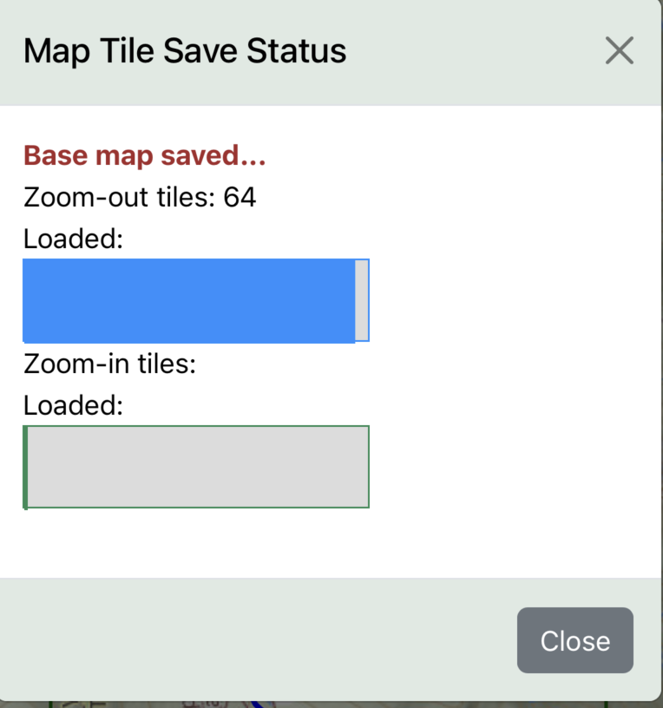

When the Save Status window shows “SAVED!”, you can close the window – the map has been saved.

- GPX File: the process is virtually the same as above, except you are going to import an existing “.gpx” file from your phone. When you tap “Choose File”, your phone will browse available locations, .e.g.
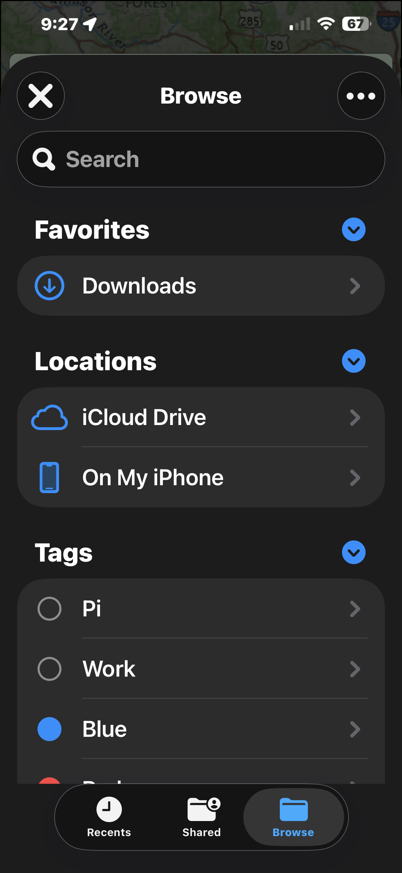
After selecting a file, simply tap the “Import GPX” button, and the
remaining process of saving is the same as previously described.

- Draw Rectangle: Use this when you are going somewhere and there is no gpx file or nmhikes.com hike to import. When you tap the ‘Draw Rectangle’, you will see the following:
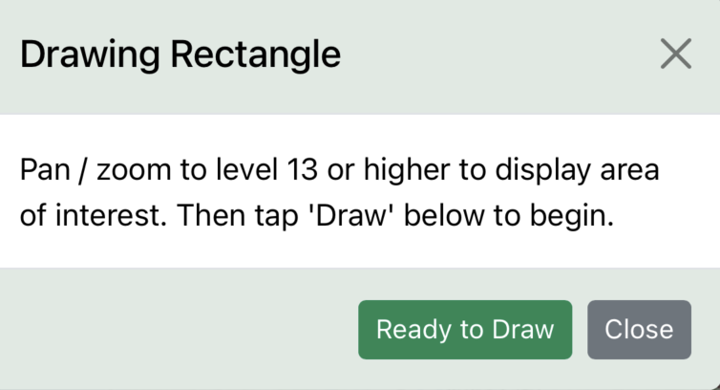

At this point, simply tap ‘Ready to Draw’, then pan anywere and zoom to the area you want to save. Note that the zoom level is always shown on the map in the upper left corner. In order to save the area, you must zoom in to zoom level 13 or higher – lower zoom levels consume too much memory. Here is an example of panning and zooming near Leadville, CO.
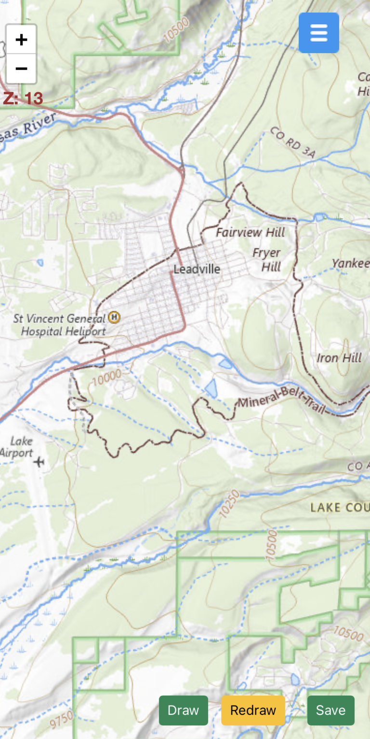

Note the buttons: Tap ‘Draw’ when you are ready
to draw a rectangle on the map with your finger.
When you are done, tap ‘Save’. If you don’t like
the area you chose, you can tap ‘Redraw’ and
then ‘Draw’ again, to get a new area.

Saving is as described previously.

NEXT you will want to use your offline map when you arrive at your destination. Internet is no longer needed! Tap the menu button, then tap “Select Map”. You are presented with a choice of the maps you saved:
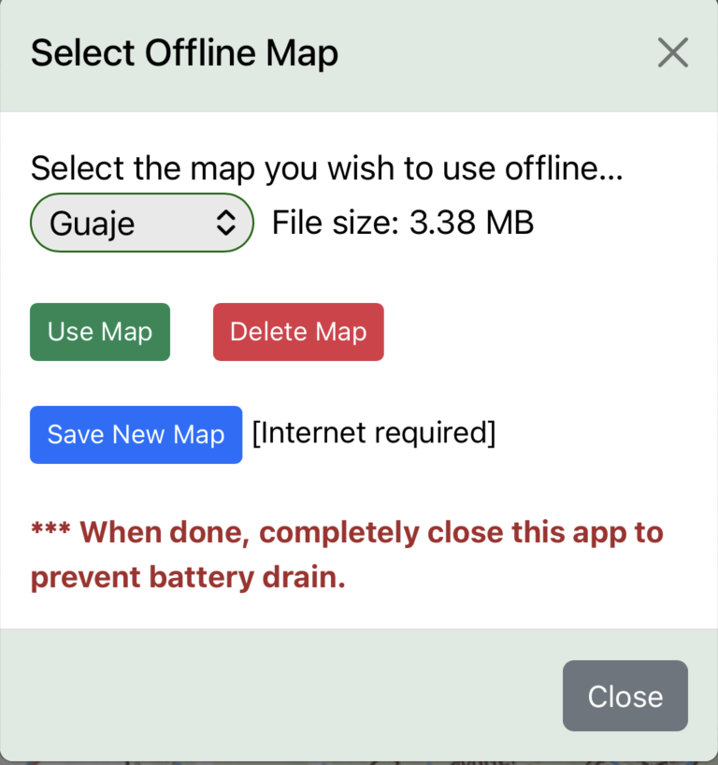

After selecting the map you wish to use in the drop-down box, you can
- Use the map displayed in the selection drop-down
- Delete the map from memory
- If you have internet, you can go back and save another map.
When you tap ‘Use Map’, the map and any track will be displayed, again internet not required.
A pulsing blue dot will indicate your location as you move around.
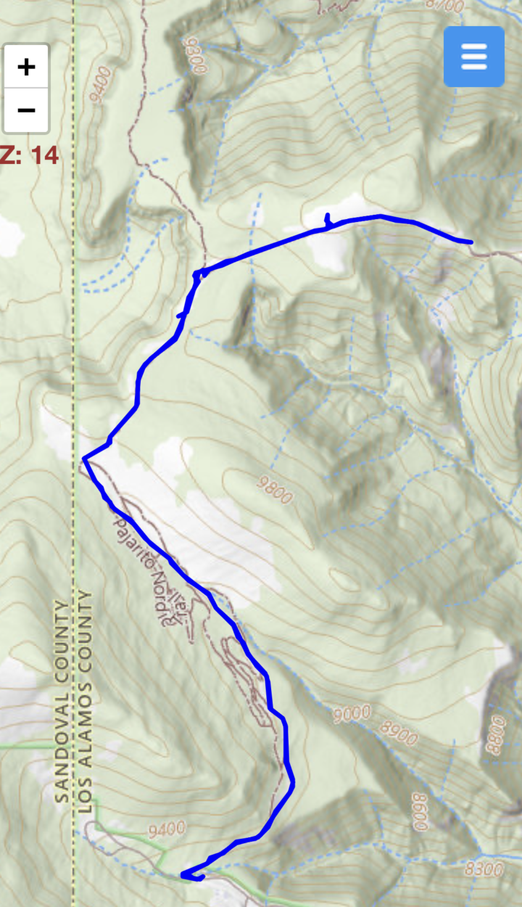

CREATING HIKE TRACKS: Online or Offline

